Bahria University,

Karachi Campus



LAB EXPERIMENT NO.

___9___

LIST OF TASKS

|  |  |
| --- | --- |
| TASK NO | OBJECTIVE |
| 1 | Create a Immutable Class of your own module. |
|  |  |

Submitted On:

____23/12/2022____

(Date: DD/MM/YY)

**Task 1:** Create a Immutable Class of your own module.

**Solution:**

using System;

namespace lab9sc

{

class Admin

{

private readonly string _AdminName;

public string AdminName

{

get { return _AdminName; }

}

private readonly int _AdminAge;

public int AdminAge

{

get { return _AdminAge; }

}

public Admin(string paramCAdminName,

int paramAdminAge)

{

_AdminName = paramCAdminName;

_AdminAge = paramAdminAge;

}

public string AData()

{

return string.Format("Hi Admin {0}", _AdminName);

}

}

}

namespace lab9sc

{

class Mainclass {

static void Main(string[] args)

{

Admin p = new Admin("electronic", 40);

Console.WriteLine(p.AData());

Console.ReadKey();

}

}

}

**Output:**

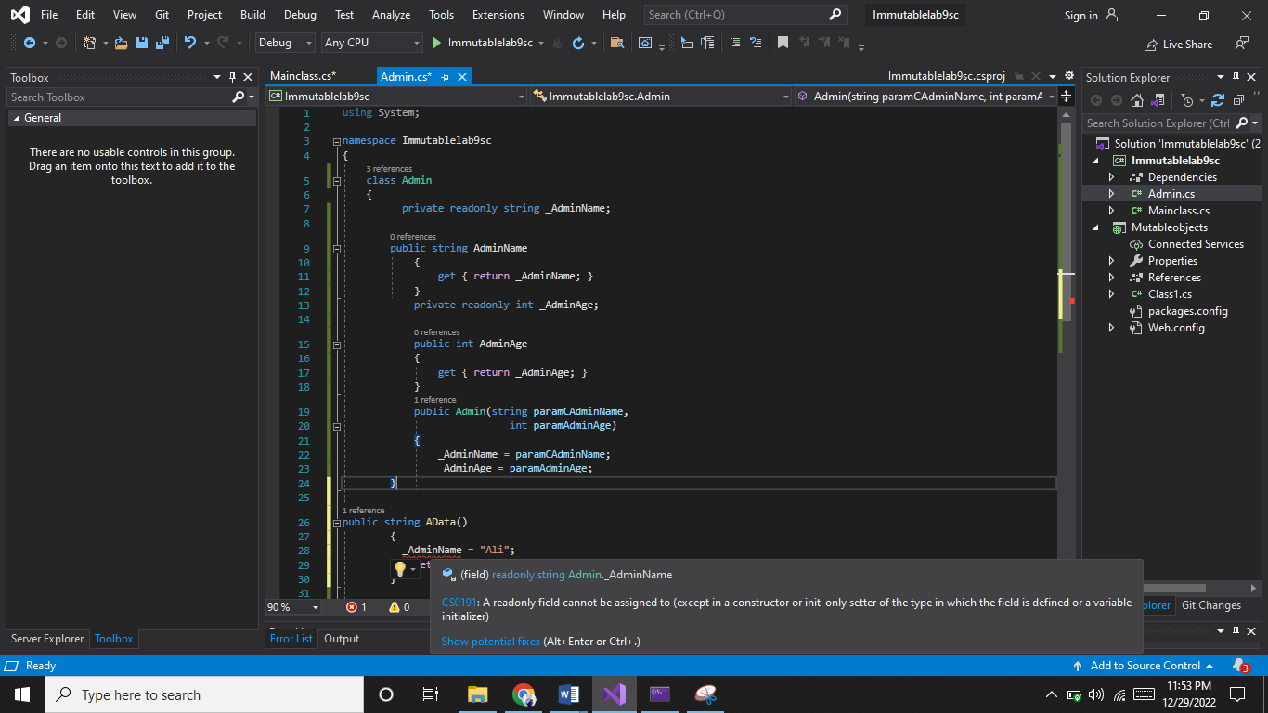Admin name can be readonly and canot be changed ,by passing in any function.

Only onetime admin name can be given and displayed through constructor

